Annex L: Baseline report on demonstration landscapes

Project: Conservation and sustainable use of indigenous agricultural genetic diversity in Hubei (C-SAP4)
UNDP PIMS: 5822 | GEF Project ID: 9873

Introduction
This document outlines descriptive profiles of three agricultural demonstration landscapes in Hubei province: two situated within the Danjiangkou Reservoir area located in the northwest corner of the province and the third situated within the central Yangtze River basin in the eastern edge of the province (see Figure L-1). The three landscapes occupy a cumulative land area of approximately 15,500 hectares (ha), as summarized below in Table L-1.
Table L-1: Summary of Three Agricultural Landscapes in Hubei Province
Target GRFA variety | Township / County | Agricultural Landscape
Target GRFA variety | Township / County | Mid-point Georeferenced Coordinates |  | Area, ha
Target GRFA variety | Township / County | Longitude | Latitude | Area, ha
Rouge rice (Oryza sative) | Baoxia / Yunyang | 110°20′11″E | 32°42′37″N | 5,000
Tao tea (Eurya alata) | Yanchihe / Danjiangkou | 111°03′03″E | 32°19′50″N | 5,300
Black goat (Capra hircus) | Sanhua / Xishui | 115°06′29″E | 30°14′21″N | 5,200
Total: |  |  |  | 15,500
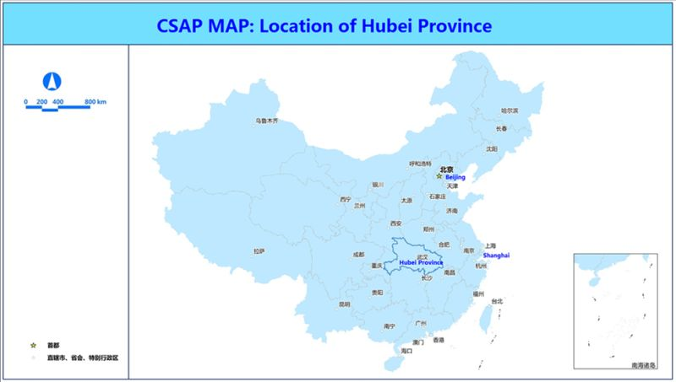
Figure L-1: Country map

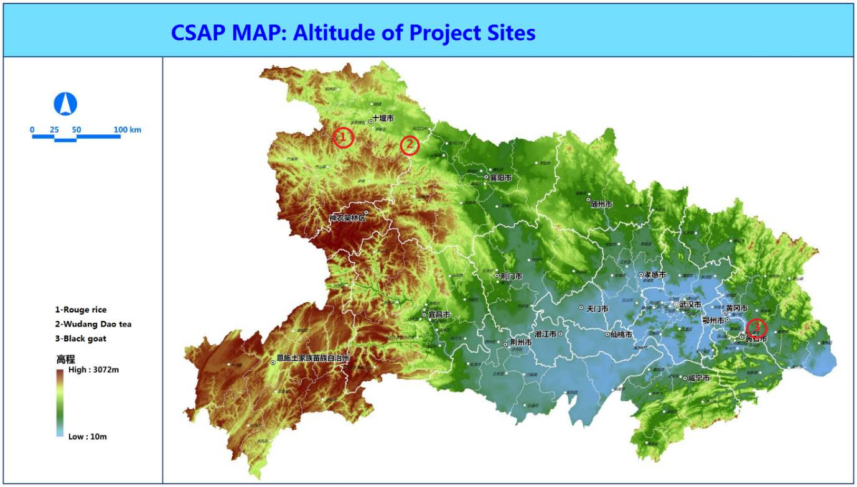
Figure L-2. Landcover map of the location of CSAP project in Hubei Province
(Landscape for Rouge rice in Yunyang county; Landscape for Wudang Tao tea in Danjiangkou County; Landscape for black goat in Xishui county)

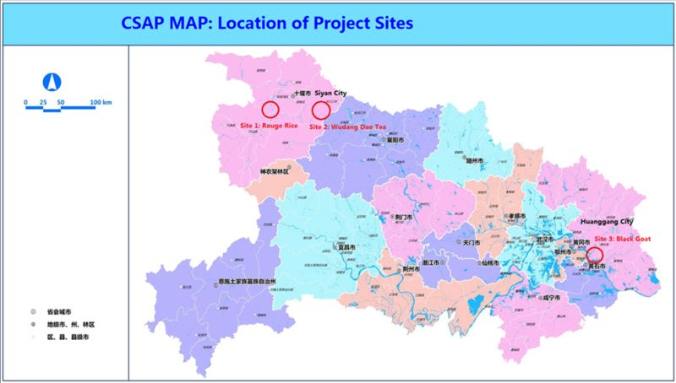
Figure L-3. Administration map of Hubei province showing locations of the three demonstration landscapes

Rouge rice landscape profile

Physical Setting
Rouge rice is planted in mountainous villages in Baoxia Township in Yunyang County, situated in the Danjiangkou Reservoir area in northwestern Hubei Province. This rice variety is planted by local farmers in broadleaf mountain valleys having elevations of approximately 1,000 m above sea level, and close to natural water supplies. The rice seed stock is located in the administrative village of Dadunzicun where 33 ha of land were cultivated with rouge rice in 2018. The demonstration landscape covers an area of approximately 5,000 ha, encompassing four villages, including Dadunzicun and three other ones, namely Canglang, Gaoqiao and Gushan. The landscape was delineated based on habitat suitability and geographical features, specifically that it is situated within the upper reaches of the Donghe River, a tributary of the Han River. This region harbors globally significant biodiversity, with the Shennongjia national natural reserve (KBA site 15663) situated nearby and within a national key ecological function zone associated with water resources. Rivers and streams within the landscape and the wider area drain into the Danjiangkou Reservoir, located on the Han River, a tributary of the Yangtze River, and an important component of the central section of the South-North Water Transfer project, where water from the reservoir is pumped north to Beijing for drinking water purposes.
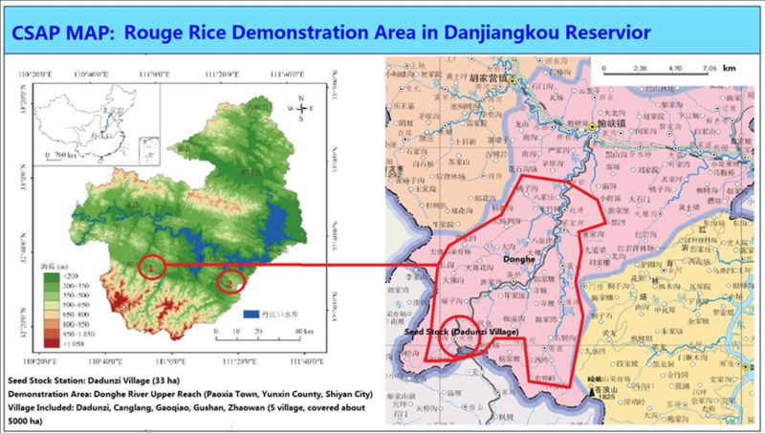
Figure L-4. Map showing locations of seeds stock and demonstration landscape for Rouge rice

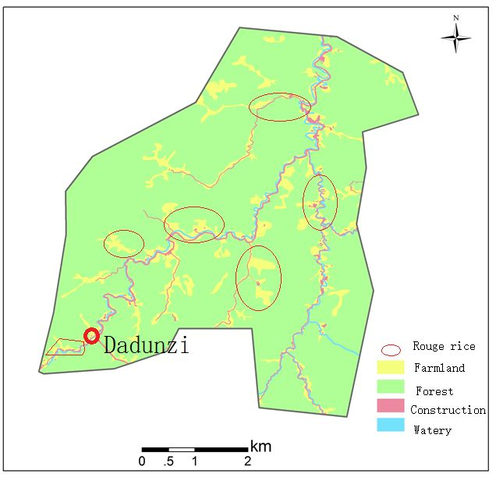
Figure L-5. Land use map of the Rouge rice demonstration landscape

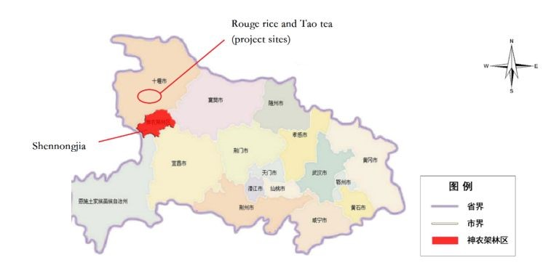
Figure L-6. Location map of Shennongjia National Nature Reserve

Summary of Agrobiodiversity Resources within the Landscape
Rouge rice is the local variety of rice (Oryza sativa) distributed in Yunyang County, Shiyan City of Hubei. It is mainly planted in mountain areas where new rice varieties are not suitable. This is also the main reason why it could be maintained until present. China is a large country with large population and less farmland. Since 1950s, Chinese government has encouraged farmers to plant improved varieties with high yield instead of local varieties with low yield to meet the food requirement for increased population. Therefore, more and more improved varieties of rice have been planted in rural areas and the number of local rice varieties become less and less. In this situation, local varieties still planted by farmers much have special characteristics such as good quality, good taste, preferable custom uses, special suitability etc. Otherwise, farmers would not keep them generation by generation.
According to local agricultural staff members and farmers, Rouge rice is preferred by local people because of its special quality with red color and good taste. Though the yield of Rouge rice is relatively low, it is typically planted in mountain valleys with the altitude of higher than 900 m where fewer pests and diseases happened often. This rice variety seems to have characteristics of cold tolerance and resistance to pests and diseases, making it a potential superior genetic resource for rice breeding in the future.
However, as the development of crop breeding technology and cultivation methods, new rice varieties with high yield, high quality, good taste, cold tolerance, pest and disease resistance, etc., could be planted even in high mountain areas. The local varieties such as Rouge rice might be lost in the nature resulted in losing the special genes and stopping the evolution process. This project focusing on conserving Rouge rice does not mean only this variety would be conserved. Rouge rice is only the representative of local varieties need to be conserved in the wild, the impacts of the project could be extended to other local varieties in Hubei.
Diversity Status: The rouge rice distributed in the Danjiangkou Reservoir upper reaches is a particularly significant reservoir of agricultural genetic diversity. This area near the boundary of Hubei, Henan and Shaanxi provinces. With 60% forest cover, the area is important ecologically and is one of 35 prioritized biodiversity protection areas in the National Biodiversity Strategy and Action Plan (2011-2030). It has also been identified as an ecological development zone in the National Plan for Regional Functioning by national environmental protection authorities. In Hubei province, about 3.5 million people are living in Danjiangkou reservoir region. Such is its diverse agrobiodiversity that the Danjiangkou Reservoir Area is known as the cradle of Chinese agriculture.
Richness: Although rice is the staple food in China and there are hundreds of rice varieties, rouge rice is an ancient variety which was providing to the Forbit City in Beijing according to the historical record. In former times, the rice was only planted in certain places for certain people, resulting in a rare rice variety.
Threats: Rouge rice is now planted over a restricted area due to habitat loss and low production. The production of rouge rice is about 250 kg per mu (667 m²), which is only 1/3 to 1/2 of ordinary rice. Furthermore, according to traditional practices, rouge rice is irrigated with clean and cool water from mountain rivers which limits its growth in low altitude region; rouge rice is typically planted in mountain valleys higher than 900 m above sea level.
Nutritional and Cultural Values: Recently scientific research suggested that rouge rice is a healthful food particularly for senior people and women. The price of rouge rice has, therefore, increased very quickly and consequently more and more farmers are interested in planting rouge rice.
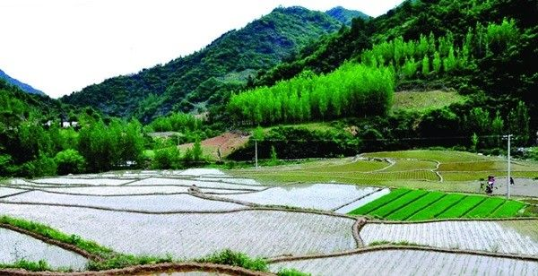
Figure L-7. Photograph of Rouge rice seed stock site (Dadunzi village)

Institutional Arrangements associated with Sustainable Use of Agrobiodiversity
The provincial institutional stakeholders involved in conservation and sustainable use of rouge rice include Hubei Provincial Department of Rural Affairs and Agriculture, which is responsible for issuing permits and eco-certifications and providing financial assistance. Support for agriculture technology methods and approaches is mainly provided by Hubei Station of Agricultural Ecology. The Shiyan City Station of Agricultural Ecology provides technical assistance in field settings to local farmers. A number of institutions at the county, township and village levels are also involved in plantation and processing of rouge rice. Among them, the Rouge Rice Farmers Cooperation in Baoxia township is an important stakeholder in the management of rice plantations.
Institutional stakeholders associated with Rouge rice
Stakeholder Group | Institutional Stakeholder | Activity
Province-level Stakeholders  (8) | Hubei Provincial Department of Agriculture and Rural Affairs | General management
Province-level Stakeholders  (8) | Hubei Provincial Department of Ecology and Environment | Environmental monitoring
Province-level Stakeholders  (8) | Hubei Provincial Department of Finance | Eco-compensation and other financial assistance
Province-level Stakeholders  (8) | Hubei Provincial Department of Water Resources | Irrigation
Province-level Stakeholders  (8) | Hubei Provincial Department of Natural Resources | Farmland protection
Province-level Stakeholders  (8) | Hubei Provincial Department Education | Ecological education
Province-level Stakeholders  (8) | Women's Federation of Hubei Province | Women’s rights
Province-level Stakeholders  (8) | Hubei Provincial Office of Poverty Alleviation | Financial support
Province-level Stakeholders  (8) | Youth League Committee of Hubei Province | Youth farmer education
Academic  Institutions  (3) | Central China Agricultural University | Plantation techniques
Academic  Institutions  (3) | Hubei University | Regional planning
Academic  Institutions  (3) | Hubei Academy of Agricultural Sciences | Agro-techniques
Local Stakeholders  (2) | Agriculture Bureau of Shiyan City, Hubei Province | Local agrobiodiversity management
Local Stakeholders  (2) | Agriculture Bureau of Yunxian County, Hubei Province | Local project management

Incentive Mechanisms and Policies
The county government has issued a regulation for rouge rice plantations, entitled as “Yunyang County Regulation for Rouge Rice Producing and Processing” (DB420321/T001-2014). This regulation prohibits the use of chemical fertilizers and pesticides. By this way, an eco-friendly agriculture culture is coming out in the rouge rice region. A local company signed contract with every farmer in spring who will plant rouge rice in coming summer. In the contract, the price and quantality had defined before the plantation, which provided a guarantee to the farmers. This model was called as “company +plantation base+farmers’ cooperation+farmer”. The national government has a policy for grain plantation: government pay the rice plantation farmers 50 CNY per mu (667 m²) per year as a compensation for food processing.
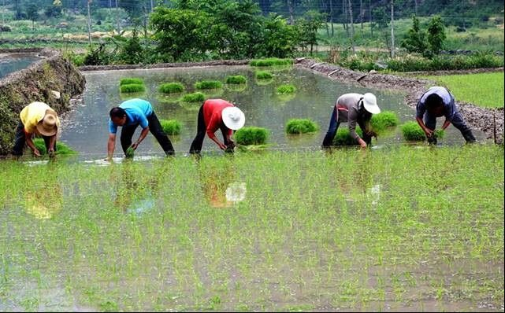
Figure L-8. Photograph of Rouge rice plantation (Canglang village)

Farmer Associations, Cooperatives and Private Sector Companies
Two local stakeholders play key roles in rouge rice plantation. One is a private company, Shiyan Rouge Valley Ecological Development Co. Ltd. The company takes charge of the supply chain of rouge rice from plantation to market. The second one is Rouge Rice Plantation Cooperative of Yunyang county. This cooperative is an official supported association which is in charge of quality control of rouge rice. The Shiyan Ding Wujie Food and Oil Trade Company is another private sector stakeholder involved in the marketing of rouge rice. There are also several farmer cooperatives that are active in the designated landscape.
Local Stakeholders |  | Classification | Location
1 | Shiyan Rouge Valley Ecological Development Co. Ltd. | Private company | Baxia town
2 | Rouge rice Association of Yunxian county | Official association | Baoxia town
3 | Shiyan Ding Wujie Food and Oil Trade Company | Private company | Shiyan City
4 | Rouge rice plantation cooperative | Farmer cooperative | Dadunzi village
5 | Rice cooperative of Canglang | Farmer cooperative | Canglang village
6 | Rice cooperative of Gaoqiao | Farmer cooperative | Gaoqiao village
7 | Rice cooperative of Gushan | Farmer cooperative | Gushan village
8 | Rice cooperative of Zhaowan | Farmer cooperative | Zhaowan village

Eco-certifications of Target GRFA Variety or Landrace
Rouge rice was issued a national “Organic Food” certificate in 2015. The certificate was issued to the Rouge rice Plantation Cooperative of Yunxian County, Shiyan, Hubei Province. The next step planned by the company is to apply for certification under the national “Geographical indication products” scheme.
Eco-certification | Status | Issued year | Issued to | Issued by
Organic food certificate (national) | Approved | 2015 | Farmers’ cooperation for Rouge rice professional plantation of Yunyang county in Shiyan | Wuyun Huaxia Center of Technology management in Beijing
Eco-labeling certificate (national) | Not applied | N/A | N/A | N/A
Geographical indication products (national) | Under application | Expected 2020 | N/A | N/A
Nuisance free products (provincial) | Under application | Expected 2019 | N/A | N/A
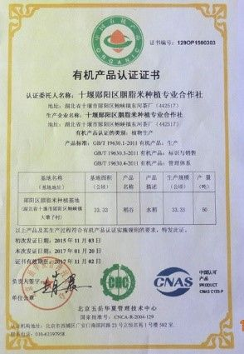
Figure L-9. Organic food certificate for Rouge rice

Current and Potential Market Demand
Rouge rice was a rare type of rice in ancient times, e.g., supplied to the Forbidden City in the Qing dynasty. For quite a long time, rouge rice disappeared from the market due to low production. In 2013, rouge rice was rediscovered in Dadunzi Village, a deep mountain valley in Western Hubei. Due to high nutrient value, the price of rouge rice increases very quickly in recent years. In 2017, the price reached CNY 300 per kg (approx. USD 44 per kg) , almost 100 times the price of ordinary rice. However, the production is still very low (366 kg per 667 m²) and the growth conditions (>1,000 m above sea level in Hubei) limit rapid expansion.

Summary of Household Socioeconomic Surveys
There are 5 villages located within the designated agricultural landscape that are involved in rouge rice plantation. As rice is not the main crop in this region, approximately 180 households (families) are expected to be direct beneficiaries on the C-SAP project, which is about 1/3 the number of total households among the 5 villages. As part of the project preparation phase, socioeconomic surveys were made at 47 households, about 25% of the total, in July 2018. The results of the surveys are summarized below.
Date of Survey: |  | July 2018 |  |  | Name of Surveyors: |  |  |  | Li Kun, Liu Yao
Landscape: | Mountainous |  |  |  | Target GRFA variety: |  |  |  | Rouge rice
County: | Yunyang |  |  | Township: |  | Baoxia |  | Villages: | Dadunzicun, Canglang, Gaoqiao, Gushan Zhaowan
Person Interviewed:
Number of households surveyed: |  |  | Average Age: |  |  |  | Gender: |  |  | Ethnicity:
47 persons (one per household) |  |  | 51.5 |  |  |  | 29 male (62%) |  |  | 100% Han
Livelihood Analysis (average):
Financial Capital:
Household income, annual in 2017: |  |  |  |  | CNY 32,600 per household (approx. USD 4,750)
Agricultural household income, % of total: |  |  |  |  | 45%
Proportion of total income from target variety, %: |  |  |  |  | 24.5%
Annual output from target variety, in 2017: |  |  |  |  | 366 kg per 667 m²
Access to markets for target varieties: |  |  |  |  | 100% cooperative
Natural Capital:
Access to farmland, hectare: |  |  |  |  | 0.12 ha per family
Type of land use arrangement: |  |  |  |  | 90% forest, 10% farmland; farmers have individual land rights, but over 80% of land rent by a company and farmers work for the company.
Main agricultural outputs: |  |  |  |  | maize, rouge rice, potato, pig, goat
Access to irrigation water resources: |  |  |  |  | easy
Access to wild agrobiodiversity: |  |  |  |  | convenient
Improved soil fertility practices: |  |  |  |  | straw return
Problems with invasive species: |  |  |  |  | none
Physical Capital:
Agricultural equipment: |  |  |  |  | Tractor, pump
Vehicles: |  |  |  |  | 0.8 per family (including auto tricycle)
Irrigation pumps: |  |  |  |  | 0.2 per family
Livestock (indicate type and numbers): |  |  |  |  | 2.37 pig per family, 1.6 goat per family
Human Capital:
Household members in agriculture (age, gender): |  |  |  |  | 1.8 per family, average age 51.5, male 60%
Use of traditional varieties into regular diet: |  |  |  |  | normal
Education attainment: |  |  |  |  | Primary school 20%, middle school 70%, high school 10%,high education 0%
Trainings received: |  |  |  |  | some
Social Capital:
Membership in cooperatives, associations, etc.: |  |  |  |  | 100% in the cooperative and association
Women or ethnic minority groups: |  |  |  |  | Belong to the government
Access to low interest credit: |  |  |  |  | 40-50% of the households have taken loans
Agriculture insurance: |  |  |  |  | Covered 78% family, household pay 50%, local government pay 50%
Most of the youth in this region are working in the cities; some of them come back to their villages for seasonal agricultural work on the family managed land. Estimations suggest only about 220 famers are involved in rouge rice plantation. Many of them are older than 55 years old. One of the key findings is that the local people are concerned about the price of rouge rice. Currently the market price for rouge rice is high because it is a rare product. If more farmers become involved in rouge rice plantation, the interviewed farmers indicated that they think the price would go down, as supply increases.

Tao tea landscape profile

Physical Setting
The Wudang Mountains make up a small mountain range in the northwestern part of Hubei Province, just south of Shiyan City. The Wudang Mountains are renowned for the practice of Tai chi and Taoism as the Taoist counterpart to the Shaolin Monastery. Tao tea (Eurya alata) is a local variety rather than conventional tea species (e.g., Camellia sinensis). This tea variety currently grows as shrubs under the forests along mountain slopes having elevations higher than 900 m above sea level. The main distribution sites are in Huangcaopu village in Yangchihe Township, Danjiangkou County; a Wudang Tao tea plantation is planned in this village. The original species are concentrated in Huangcaopo Mountain with an area more than 1,200 ha. The demonstration landscape for the project covers an area of approximately 5,300 ha, delineated on the basis of habitat suitability for Eurya alata shrubs and traditional harvesting in the wild. Demonstration activities are planned to focus in Huangcaopu village. There are three other villages, namely Qixinghe, Liujiahe and Gaiban, situated in the demonstration landscape where Wudang Tea plantations have been considered by local stakeholders.
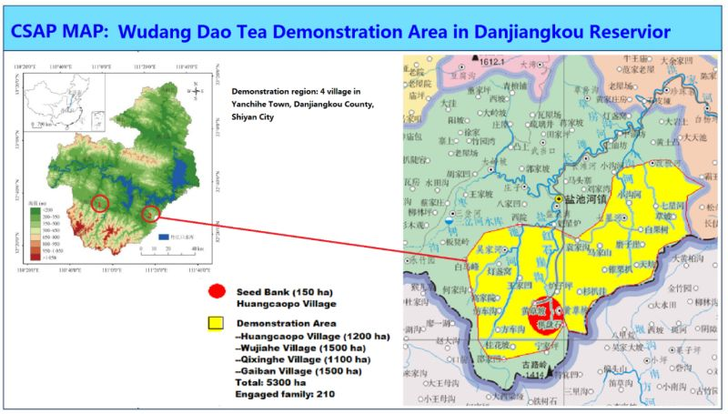
Figure L-10. Map of physical setting of Wudang Tao tea of Danjiangkou County

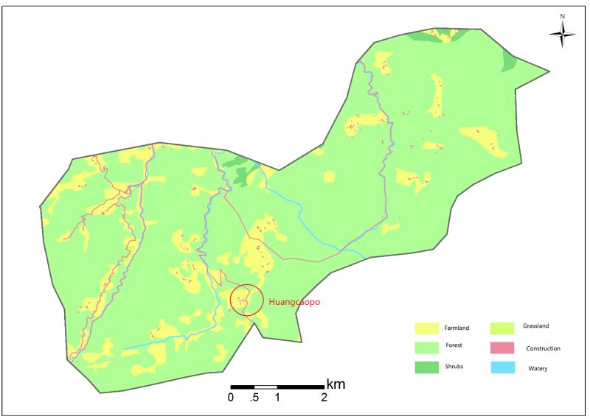
Figure 11. Land use map of Wudang Tao tea demonstration landscape

Summary of Agrobiodiversity Resources within the Landscape
In fact, Tao tea is not a kind of tea tree. It is a local special tea which is made from leaves of a tree species named Eurya alata which also belong to the family of Theaceae. Wudang Tao tea is famous because it is related to a well-known religion called “Taoist Religion” or “Taoism”. Taoism is referring to a variety of related Chinese philosophical traditions and concepts. These traditions influenced East Asia for over two thousand years and some have spread internationally. An emphasis of Taoism is placed on the link between people and nature, and Taoists generally use fruits, leaves, or roots of different trees for their health. Through long time trials, they found the leaves of Eurya alata has healthy function with good taste like tea. Therefore, Tao tea has been a favorite drinking of Taoists for thousands of years and used generation by generation. As the development of China economy, some companies found the values of Tao tea and develop them as a famous brand. These commercial activities made more people share the healthy plant and the farmers who collect the leaves increased income. As the result, local governments also encourage companies and farmers to cultivate the plants for the purposes of priority reduction for farmers.
Similar to other parts of the world, as economic development continues to expand in China, people are seeking for better lives especially for healthy food. Tao tea would provide more choices to meet people’s needs of not only Chinese people, but also the global residents with opening policy in China. Moreover, the traditional knowledge related with Tao tea created by Taoists could also be shared by more people in the World. Therefore, Tao tea and related traditional knowledge are significant China and global biodiversity. However, because of the limited technology and suitable planting area, the quality of Tao tea made from the leaves of cultivated plants is not as the same as those from wild plants. More and more farmers climb to the mountains to collect leaves of wild plants and sometime cut branches of large trees or remove young trees to their gardens for easy collecting, resulting in the decrease of genetic diversity of Eurya alata.
In modern agriculture activities, it is recognized that breeding (including propagation) and cultivation would decrease genetic diversity of crops. At present, Wudang Tao tea are cultivated by only 3 farms where the generated plants might be from only several individual trees with narrow genetic background. While the young trees removed by farmers might be dead or change their own characteristics due to the different environments and limited planting methods. Tao tea is not only a kind of trees for drinking but also an important culture for Taoists and local people. The decreasing genetic diversity would be harmful for both commercialization and Taoism. In order to make Tao tea more popular and benefit for people especially for local farmers in the future, conserving the tree diversity of Eurya alata properly in the wild and developing suitable cultivating technologies should be attached great importance.
Diversity Status: Tao tea in the Wudang Mountains is a historical natural shrub with name of Eurya alata Kobuski. It is not from the Camellia sinesis family of plants that are often considered ordinary tea. In ancient days, the local people and Taoists drank this tea rather than ordinary tea. It is shrub of 1-3 m tall. Young branches are grayish brown. Leaf blades are yellowish green, adaxially dark green and shiny, both surfaces glabrous, midvein abaxially elevated and adaxially impressed. The young leaves are collected as raw tea in late spring and early summer. The old leaves are not cultivated. Eurya alata mainly distributes in Western Hubei and South Sanxi province. It grows much higher and better than in Shanxi. So far only in Wudangshan it is processed as tea. In Wudangshan, it occupies about 20-50 km² on the mountains.
Richness: Tao tea tree is a wild shrub growing in the higher altitudes in the Wudang Mountains, usually higher than 900 m above sea level. In the village of Huangcaopo, the occurrence of Tao tea might reach 30 individuals per 1 mu (667 m²).
Evenness: Tao tea trees are not randomly distributed but closed together under the forest cover. In its habitats, Tao tea can cover 50-70% of forest floor. The shrubs are less common on dry slopes.
Threats: There are only 3 small family plantation farms planting Tao tea. Most of Tao tea leaves are still collected from the nature. This is the heaviest threat to Tao tea trees. Artificial plantation is critically needed.
Nutritional and Cultural Values: In ancient time before the Common Tea was planted in Mountain Wudangshan, Tao tea was the main drinking Tea in this region. Which was entitled as Tao Tea indicating it is Taoist’s tea.

Institutional Arrangements associated with Sustainable Use of Agrobiodiversity
The provincial institutions involved in the conservation and sustainable use of Tao tea include the Hubei Provincial Department of Rural Affairs and Agriculture, which is responsible for issuing permits and eco-certifications and providing financial assistance. Support for agriculture technology methods and approaches is mainly provided by Hubei Station of Agricultural Ecology. The Shiyan City Station of Agricultural Ecology provides technique assistance in field settings to local farmers. The Association of Wudang Tao Tea in Shiyan is in charge of the plantation, processing and marketing of Tao tea. One private company, Dao Tea Processing Company in Wudangshan is involved in Tao tea processing. One local cooperative, Wudang Tao Tea Cooperative in Huangcaopo, will be involved in Tao tea plantation.

Incentive Mechanisms and Policies
Tao tea is a market concept for tea produced in the Wudang Mountains. The leaves of the shrub have a tea taste and shape but without theophylline. So far most of Tao tea is directly harvested from the wild. The local government worries about the sustainable utilization of this wild species and has encouraged local farmers in planting Tao tea trees to increase the production of raw leaves. Since collecting of leaves is not damaging to the trees, it is recognized an ecological plantation by local government thereby the plantations are able to get ecological compensation on the item of “shift farmland to forest” by the provincial Department of Natural Resources (Forestry Bureau).
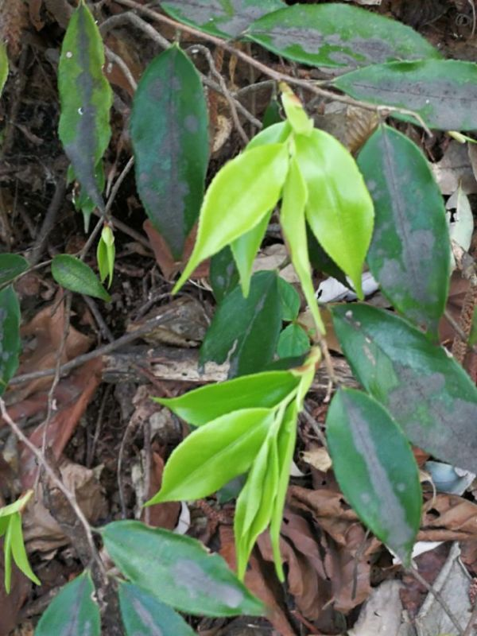 | 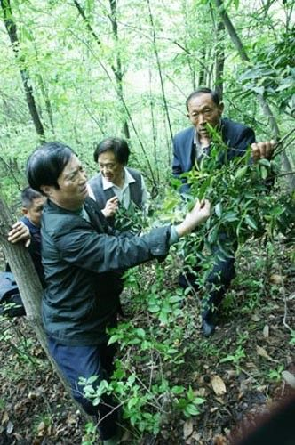
Figure L-11. Young leaves of Tao tea (Eurya alata) | Figure L-12. Collection of Tao tea from nature
Institutional stakeholders associated with Tao tea
Stakeholder Group | Institutional Stakeholder | Activity
Province-level Stakeholders  (9) | Hubei Provincial Department of Agriculture and Rural Affairs | General management
Province-level Stakeholders  (9) | Hubei Provincial Department of Ecology and Environment | Environmental monitoring
Province-level Stakeholders  (9) | Hubei Provincial Department of Finance | Eco-compensation and other financial assistance
Province-level Stakeholders  (9) | Hubei Provincial Forestry Bureau (Dept Natural Resources) | Tao tea plantation administration
Province-level Stakeholders  (9) | Hubei Provincial Department of Water Resources | Irrigation
Province-level Stakeholders  (9) | Hubei Provincial Department of Natural Resources | Farmland protection
Province-level Stakeholders  (9) | Hubei Provincial Department Education | Ecological education
Province-level Stakeholders  (9) | Women's Federation of Hubei Province | Women’s rights
Province-level Stakeholders  (9) | Hubei Provincial Office of Poverty Alleviation | Financial support
Province-level Stakeholders  (9) | Youth League Committee of Hubei Province | Youth farmer education
Academic  Institutions  (3) | Central China Agricultural University | Plantation techniques
Academic  Institutions  (3) | Hubei University | Regional planning
Academic  Institutions  (3) | Hubei Academy of Agricultural Sciences | Agro-techniques
Local Stakeholders  (2) | Agriculture Bureau of Shiyan City, Hubei Province | Local project management
Local Stakeholders  (2) | Agriculture Bureau of Danjiangkou County, Hubei Province | Local agrobiodiversity protection management

Farmer Associations, Cooperatives and Private Sector Companies
There are four key local stakeholders who will be involved in the Tao tea demonstration project. One is Hubei Wudang Tao Tea Industry Association, a government-supported association that may take the responsibility for market development of Tao tea. The second stakeholder is Hubei Shenwu Tao Tea Development Company, a private company. It will take part the project for tea processing. The third one is Shizifeng Tea Cooperative Farmers’ cooperative in Yanchihe town. It will plant Tao ten in their farm. The fourth stakeholder is Huangcaopo Tao Tea Cooperative. The farmers in that cooperative plant Tao tea in their village as their main economic product.
Local Stakeholders |  | Classification | Location
1 | Hubei Wudang Tao Tea Industry Association | Government-supported association | Shiyan City
2 | Hubei Shenwu Tao Tea Development Co. Ltd. | Private company | Tuguanya town
3 | Shizifeng Tea Cooperative | Farmers’ cooperative | Yanchihe town
4 | Huangcaopo Tao Tea Cooperative | Farmers’ cooperative | Dadunzi village

Eco-certifications of Target GRFA Variety or Landrace
There are three main types of eco-certifications for the tea in China. Tao tea has not been issued any certifications to date. However, the Shizifeng Tea Cooperative and Huangcaopo Tao Tea Cooperative have indicated that they plan to apply for each of the three types of certificates.
Eco-certification | Status | Issued year | Issued to | Issued by
Organic food certificate (national) | None | Expected 2022 | N/A | N/A
Eco-labeling certificate (national) | None | Expected 2022 | N/A | N/A
Geographical indication products (national) | None | Expected 2021 | N/A | N/A
Nuisance free products (provincial) | Under application | Expected 2019 | N/A | N/A

Current and Potential Market Demand
Tao tea has a stable market among those people who like to drink tea but dislike theophylline. The price of Tao tea from wild trees reached more than CNY 2,000 per kilogram (approx. USD 300) in 2017. The Wudang Mountains region is the location of an internationally famous Taoist temple, since Wudangshan is a World Culture Heritage issued by UNESCO. Tao tea is a favorite gift among the visiting tourists and Taoists.
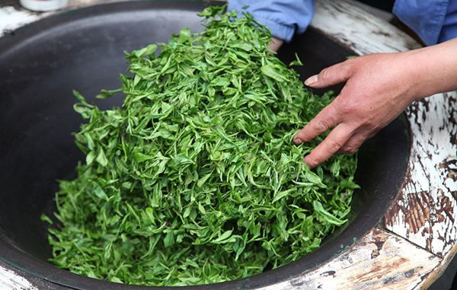 | 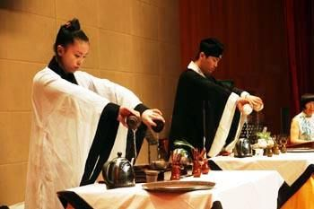
Figure L-13. Photographs of processing and serving Tao tea (green tea)

Summary of Household Socioeconomic Surveys
There are 4 villages located within the designated agricultural landscape that will be involved in the Tao tea demonstration project. There are about 210 famers involved in Tao tea plantation. The total number of people involved in cultivating Tao tea may reach 260 farmers. Since Wudangshan is tourist region. many farmers are working in the town while in the agricultural season they participate the agricultural activities. As part of the project preparation phase, socioeconomic surveys were made at 45 households, about 21% of the total, in August 2018. The results of the surveys are summarized below.
Date of Survey: |  | August 2018 |  | Name of Surveyors: |  |  |  | Li Kun, Feng Haiping
Landscape: | Mountainous |  |  | Target GRFA variety: |  |  |  | Tao tea
County: | Danjiangkou |  |  | Township: |  | Yanchihe |  | Villages: | Huangcaopo, Qixinghe, Liujiahe, Gaiban
Person Interviewed:
Number of households surveyed: |  |  | Average Age: |  |  |  | Gender: |  |  | Ethnicity:
45 persons (one person per household) |  |  | 51.1 |  |  |  | 37 male (82%) |  |  | 100% Han
Livelihood Analysis (average):
Financial Capital:
Household income, annual in 2017: |  |  |  |  | CNY 47,100 per household (approx. USD 6,850)
Agricultural household income, % of total: |  |  |  |  | 38%
Proportion of total income from target variety, %: |  |  |  |  | 2.06%
Annual output from target variety, in 2017: |  |  |  |  | 0.438 kg
Access to markets for target varieties: |  |  |  |  | 100% sale
Natural Capital:
Access to farmland, hectare: |  |  |  |  | 0.07 ha per family
Type of land use arrangement: |  |  |  |  | 60% forest, 32% economic plant gardening, 8% farmland, land belongs to individual family
Main agricultural outputs: |  |  |  |  | Tea (including Tao tea), maize, pig, honey bee
Access to irrigation water resources: |  |  |  |  | easy
Access to wild agrobiodiversity: |  |  |  |  | convenient
Improved soil fertility practices: |  |  |  |  | Organic fertilizer
Problems with invasive species: |  |  |  |  | none
Physical Capital:
Agricultural equipment: |  |  |  |  | Tractor, pump etc.
Vehicles: |  |  |  |  | 0.95 per family
Irrigation pumps: |  |  |  |  | 0.3 per family
Livestock (indicate type and numbers): |  |  |  |  | 2.2 pig per family, 0.3 calf per family
Human Capital:
Household members in agriculture (age, gender): |  |  |  |  | 2.1 per family，average age 51.1
Use of traditional varieties into regular diet: |  |  |  |  | normal
Education attainment: |  |  |  |  | Primary school 11%, middle school 69%, high school 16%, high education 4%
Trainings received: |  |  |  |  | some
Social Capital:
Membership in cooperatives, associations, etc.: |  |  |  |  | 100% in the cooperative and association
Women or ethnic minority groups: |  |  |  |  | Women association, youth association
Access to low interest credit: |  |  |  |  | 90% of the households have taken low interest loans
Agriculture insurance: |  |  |  |  | Covered 100% family (farmer pay 50%, government pay 50%)
Household annual income reached CNY 47,100 (approx. USD 6,850) in 2017. However, income from Tao tea is only 2.06% of the total because at this moment the tea can only be collected from the wild.

Black goat landscape profile

Physical Setting
The Dabieshan black goat in Hubei province is a Geographical Indication variety mainly distributed in eastern Hubei Province, including in Xishui county. The core area of the black goat is located at Yugang village in Sanhua township. The demonstration landscape for the black goat GRFA variety covers an area of approximately 5,200 ha, delineated based on geographic features, situated between the Yangtze River and Cehu Lake and based on traditional breeding practices. The rich grasslands in the landscape have supported black goat breeding for hundreds of years, providing a stable food source and a source of organic fertilizer (from animal wastes) for surrounding farmlands. Demonstration activities are planned in Yugang village occupying approximately 1,200 ha. Among the reported 667 households in Yugang village in 2018, there are 30 poverty-stricken households with 78 inhabitants. The cultivated area of the village is 53 ha, which includes 26.6 ha of rice paddy area. The water surface area is 53 ha, and the area of returning farmland to forest (fruit orchard) is 63 ha. There are six professional agricultural cooperative organizations of planting and breeding of greenhouse vegetables, the kiwi fruit, citrus, mulberries, blueberries, aquatic products, and Dabie mountain black goat. These cooperatives form a circular ecological agriculture base, with sustainable development of crop cultivation, animal husbandry, processing of agricultural products, agro-ecotourism and in-situ conservation of local genetic resources. There are 8 other villages within the landscape having a cumulative land area of about 4,000 ha.
Yugang village is a typical village of "the east of Yangtze River - Dabie mountains area". The promotion of the project could potentially reach 15 counties in the area of the east of Yangtze river- Dabie mountains, with a population of 10 million and an area of nearly 30,000 square kilometers. The implementation of the project follows the national strategy of "Yangtze River protection", rural revitalization and beautiful village construction. A few of the priorities of this strategy include:
- Sustainable ecological model of recycling of crop and breeding waste.
- Promotion and conservation of genetic diversity resources of local agricultural varieties.
- Protection of national key protection breeds, such as wild kiwi fruit and Dabie mountain black goat.
- In-situ biodiversity and ecosystem services conservation.
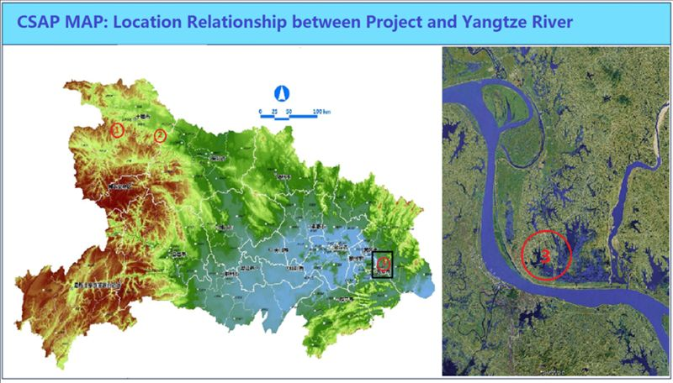
Figure L-14. Location map of black goat demonstration landscape

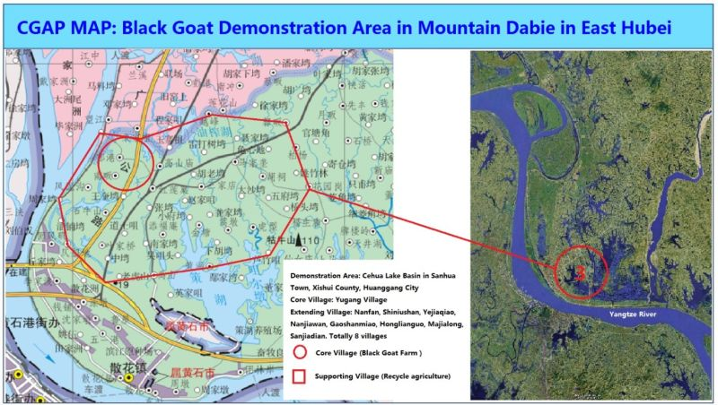
Figure L-15. Vicinity map of the black goat demonstration landscape

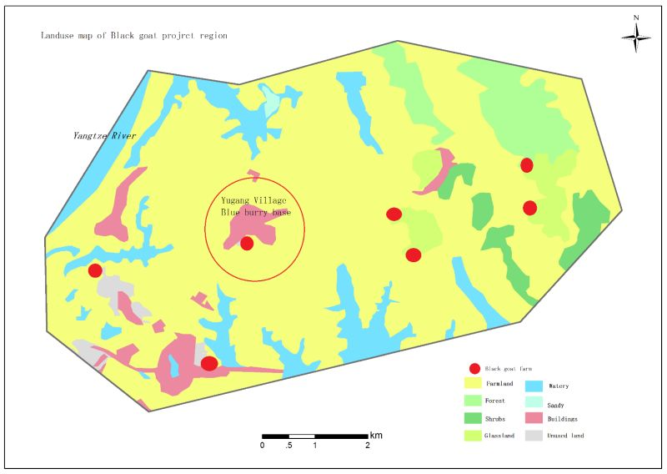
Figure L-15. Land-use map of the black goat demonstration landscape

Summary of Agrobiodiversity Resources within the Landscape
Black goat is a kind of goat with black hairs. The Black goat in Xishui county of Hubei refers to the local variety which has not been hybrid with other varieties. This variety has its special quality such as tender meat, good taste, less rank odor, high protein and low fat and cholesterol contents etc. comparing with other goats. It is said by local farmers that the meat of the Black goat has healthy functions to increase immunity, prolonging life, helping patients’ recovering etc., but there is no scientific evidence for these functions. Whatever it is true local people like Black goat meat very much.
Black goat in Xishui was the registered variety of livestock gene pool in China which has 575 local varieties of every kinds of livestock. These local varieties are recognized to be potential breeding parents for livestock improvement in the future, because they had different and special characteristics which could provide abundant genes to meet the requirements of livestock markets in both China and the World. However, because the Black goats grow much slower than other varieties, less and less farmers feed the Black goats in recent years. Thus, the numbers of black goats are decreasing quickly. More importantly, local farmers and companies feed more new varieties of goat introduced from outside, the introgression of genes between Black goat and other goats would also be harmful for keeping the genetic purity of Black goat. These factors above might decrease the genetic diversity of the black goat. Therefore, as the project’s main tasks, conservation and sustainable utilization of the Black goat are also the priority for Chinese government.
Diversity Status: The Dabieshan mountain black goat, distributed in Dabieshan mountains area at the junction of three provinces of Hubei, Henan, and Anhui, is mainly formed by self-breeding, group feeding, and long-term directional selecting. This variety of black goat is also called dusty sheep, brown sheep, green grey sheep and Macheng black goat. In the year of 2002, it was officially named "Macheng black goat" by the livestock and poultry breeds review committee of Hubei province. And in the year of 2009, it is passed the identification by the national livestock and poultry genetic resources committee and was selected in the category of national livestock and poultry genetic resources.
Threats: The threats to the black goat include the followings: (1) cross breeding from other goat varieties; (2) degradation of genetic resources; (3) foot rot disease.
Coverage: The main coverage area of Black goat is in Eastern Hubei such as Xishui, Macheng and Luotian county. Black goat mainly distributes in hilly area, with the average elevation above 250m, the average annual temperature 12.8-16.1℃, annual relative humidity 70%-80%, annual sunshine time 2036.7-2153.1h, and annual precipitation 1067-1475mm.
Richness: Mainly distributed in mountainous areas and hills, characterized by uncultivated land. It is estimated that there are about 100,000 black goats in Hubei province, and another 40,000 in Anhui province.
Nutritional and Cultural Values: Black goat weight up to 35 kg to 58 kg. The black goat meat is nutrient-rich food. The amount of milk produced by the ewe is of 106 kg per year.
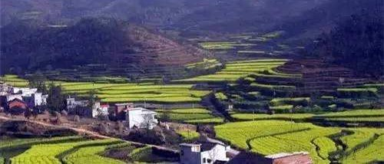
Figure L-16. Photograph of circular agriculture in Yugang village
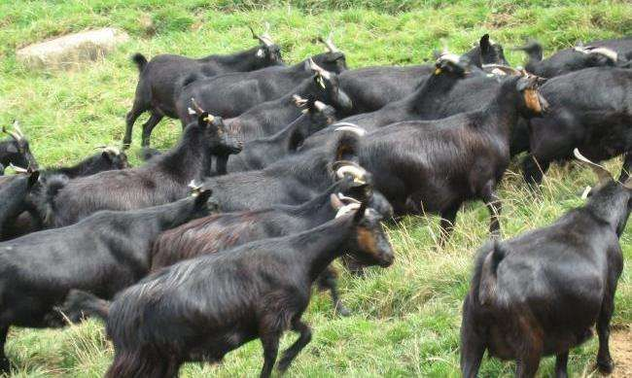
Figure L-17. Black goat in Dabieshan Mountain (Geographical indication variety)

Institutional Arrangements associated with Sustainable Use of Agrobiodiversity
The provincial institutions involved in the conservation and sustainable use of black goat include the Hubei Provincial Department of Rural Affairs and Agriculture, which is responsible responsibility for issuing permits and eco-certifications and providing financial assistance. Support for agriculture technology methods and approaches is mainly provided by Hubei Station of Agricultural Ecology and Hubei Academy of Agriculture. The Huanggang City Station of Agricultural Ecology and Huanggang City Bureau of Animal Husbandry provides technical assistance in field settings to local farmers. One strong farmer cooperative, The Hengrui professional Cooperative of Blueberry Planting in Yugang village is an important stakeholder representing farmers directly.
Institutional stakeholders associated with Black Goat
Stakeholder Group | Institutional Stakeholder | Activity
Province-level Stakeholders  (8) | Hubei Provincial Department of Agriculture and Rural Affairs | General management
Province-level Stakeholders  (8) | Hubei Provincial Department of Ecology and Environment | Environmental monitoring
Province-level Stakeholders  (8) | Hubei Provincial Department of Finance | Eco-compensation and other financial assistance
Province-level Stakeholders  (8) | Hubei Provincial Department of Water Resources | Irrigation
Province-level Stakeholders  (8) | Hubei Provincial Department of Natural Resources | Farmland protection
Province-level Stakeholders  (8) | Hubei Provincial Department Education | Ecological education
Province-level Stakeholders  (8) | Women's Federation of Hubei Province | Women right
Province-level Stakeholders  (8) | Hubei Provincial Office of Poverty Alleviation | Financial support
Province-level Stakeholders  (8) | Youth League Committee of Hubei Province | Youth farmer education
Academic  Institutions  (3) | Central China Agricultural University | Plantation techniques
Academic  Institutions  (3) | Hubei University | Regional planning
Academic  Institutions  (3) | Hubei Academy of Agricultural Sciences | Agro-techniques
Local Stakeholders  (4) | Agriculture Bureau of Huanggang City, Hubei Province | Local project management
Local Stakeholders  (4) | Agriculture Bureau of Xishui County, Hubei Province | Local agrobiodiversity protection management
Local Stakeholders  (4) | Huanggang City Bureau of Animal Husbandry | Technical support
Local Stakeholders  (4) | Xishui County Bureau of Animal Husbandry | Technical support

Incentive Mechanisms and Policies
Black goat has been bred in Dabieshan mountains as a livestock for at least 1,000 years. Since it is usually living in the mountainous regions and feeding on natural grass, people think their meat is healthful. Consequently, the price is usually much higher than ordinary goat meat. The local government encourages the famers breeding black goat and provide financial assistance.

Farmer Associations, Cooperatives and Private Sector Companies
There are 5 farmer organizations involved in the black goat production in the demonstration landscape. The largest cooperative is the Hengrui professional cooperative of blueberry planting in Xishui country, founded in July 2015 by seven Yugang villagers. The total investment is CNY 6 million (approx. USD 875,000) and the area of transferred land and water is 33 ha. The cooperative grows blueberries with an area of 13 ha, citrus of 7 ha, water surface of 13 ha, and raise 300 Dabie mountain black goat. An agricultural sightseeing leisure food service center, and fruit packaging and transportation processing center have been built. This cooperative is a pillar enterprise of Yugang village, with a net income of CNY 0.60 million (approx. USD 87,500) in 2017. After the project implementation, the annual net income was increased to 1.20 million CNY, 120 seasonal posts were provided to the farmers nearby, and the annual income of famers was increased by 1.50 million CNY. Also, it can drive the blueberry planting in surrounding township over 30 ha, and breeding more than 300 black goats.
The second organization is the Yurui professional cooperative of agricultural planting in Xishui country, founded in July 2015 by five Yugang villagers. The total investment is CNY 5 million (approx. USD 725,000) and the area of transferred land and water is 30 ha. It grows Chinese gooseberry with an area of 20 ha, greenhouse vegetables of 13 ha. After two years of the project implementation, the annual net income reached CNY 0.80 million (approx. USD 115,000) in 2017. After five years of the project implementation, the annual net income is expected to reach CNY 1.3 million (approx. USD 190,000), 120 seasonal posts will be provided to the farmers nearby, and the annual income of famers will be increased by CNY 1.5 million (approx. USD 220,000). Also, the cooperative plans to expand plantation of Chinese gooseberry planting in surrounding the township to about 1300 ha.
Local Stakeholders |  | Classification | Location
1 | Huanggang Dabieshan Black goat Association | Government-supported association | Huanggang City
2 | Hengrui professional cooperative of blueberry planting | Farmers’ cooperative | Yugang village, Sanhua township
3 | Yurui professional cooperative of agricultural planting | Farmers’ cooperative | Yugang village, Sanhua township
4 | Yugang Dabieshan black goat cooperative | Farmers’ cooperative | Yugang village
5 | Yugang greenhouse vegetable cooperative | Farmers’ cooperative | Yugang village

Eco-certifications of Target GRFA Variety or Landrace
Provide information on existing eco-certifications for the target variety and landrace in the landscape; also include information on certifications that under process, but not yet issued. Information can be presented in tabular form.
Dabieshan black goat was approved as Geographical Indication Product in 2016. The application of Eco-lab production is in preparation and might provide application in the year of 2020.
Eco-certification | Status | Issued year | Issued to | Issued by
Organic food certificate (national) | N/A | N/A | N/A | N/A
Eco-labeling certificate (national) | Application | Expected 2020 | N/A | N/A
Geographical indication products (national) | Approved | 2016 | Huanggang city | Chinese National Bureau of Quality Inspection
Nuisance free products (provincial) | N/A | N/A | N/A | N/A

Current and Potential Market Demand
The Dabie mountain black goat is a kind of high-quality goat with dual-use skin and flesh, and it is formed by years of selective breeding and purification of local fine goats in Dabie Mountains area. This goat is tall and big, with genetic stability. It has the advantages of fast growth, good fattening ability, high slaughtering rate and net meat string, good meat quality, light odor, good tolerance to coarse feeding and strong adaptability. Consequently, it is a good goat breed of skin and flesh dual-use, is also the protected object of germplasm resources “black goat” proposed by agriculture ministry. Xishui is only about 100 km away from Wuhan, a National Centering City with the population over 12 million. This huge market is waiting for high quality goat meat.

Summary of Household Socioeconomic Surveys
One core village and 8 extending villages will be involved in the black goat project. There are about 112 households that are expected to be involved in the project. As part of the project preparation phase, socioeconomic surveys were made at 41 households, about 37% of the total, in August 2018. The results of the surveys are summarized below.
Date of Survey: |  | August 2018 |  | Name of Surveyor: |  |  |  | Li Kun, Gao Shan
Landscape: | Small hill |  |  | Target GRFA variety: |  |  |  | Black goat
County: | Xishui |  |  | Township: |  | Sanhua |  | Village: | Yugang
Person Interviewed:
Number of households surveyed: |  |  | Average Age: |  |  |  | Gender: |  | Ethnicity:
41 persons (one person per household) |  |  | 52.6 |  |  |  | ... |  | ...
Livelihood Analysis (average):
Financial Capital:
Household income, annual in 2017: |  |  |  |  | CNY 87,000 per household (approx. USD 12,700)
Agricultural household income, % of total: |  |  |  |  | 63.7%
Proportion of total income from target variety, %: |  |  |  |  | 50.3%
Annual output from target variety, in 2017: |  |  |  |  | CNY 49,800 per household (approx. USD 7,250)
Access to markets for target varieties: |  |  |  |  | 100%
Natural Capital:
Access to farmland, hectare: |  |  |  |  | 7.98 ha per family
Type of land use arrangement: |  |  |  |  | 60% farmland,40% forest and others, farmland belong to the individual households, the cooperation hire land from household for utilization, local farmers usually work in the cooperation
Main agricultural outputs: |  |  |  |  | rice, cotton, black goat, pig
Access to irrigation water resources: |  |  |  |  | 72.5% farmland
Access to wild agrobiodiversity: |  |  |  |  | easy
Improved soil fertility practices: |  |  |  |  | Organic fertilizer, straw return to land
Problems with invasive species: |  |  |  |  | Alternanthera philoxeroides around water bodies
Physical Capital:
Agricultural equipment: |  |  |  |  | tractor, pump, motorcycle, etc.
Vehicles: |  |  |  |  | 0.8 per family
Irrigation pumps: |  |  |  |  | 0.3 per family
Livestock (indicate type and numbers): |  |  |  |  | 104 goat per family
Human Capital:
Household members in agriculture (age, gender): |  |  |  |  | 3 per family
Use of traditional varieties into regular diet: |  |  |  |  | normal
Education attainment: |  |  |  |  | Primary school 32.5 %, middle school 42.5 %, high school 17.5 %, high education 2%
Trainings received: |  |  |  |  | frequently
Social Capital:
Membership in cooperatives, associations, etc.: |  |  |  |  | 70% in the cooperative and association
Women or ethnic minority groups: |  |  |  |  | Women association, youth association
Access to low interest credit: |  |  |  |  | 100% of the interviewed households have taken loans
Agriculture insurance: |  |  |  |  | Covered 100% household (farmer pay 50%, government pay 50%)
Because of the location of the villages is quite good in terms of infrastructure and access to markets, the famers in this region are relatively rich. The family annually income can reach CNY 87,000 (approx. USD 12,700).

Chen J.W. el al. Plantation technologies of Ninghai Rouge Rice in high mountains. Shanghai Agricultural Science and Technology, 2014(04):65

